Movement of substances across the plasma membrane
In order for the cell cytoplasm to communicate with the external environment, materials must be able to move through the plasma membrane, which is act as semi –permeable barrier that allow some substances to pass the membrane but not others.
Substances can pass across the membrane depends not only on the particles of substances themselves but also on additional consideration like how much of substance is already on each side of the membrane (concentration gradient), or on the availability of energy to support the process because some transport mechanism require energy to be provided by the cell in order for certain types of substances to be moved from one side of the membrane to the other.

There are two types of transport mechanisms by which molecules traverse membrane:
1-Mecanisms do not require energy for movement the material across plasma membrane (described as passive) is the movement of molecules or ions from an area of higher to lower concentration; mechanism does not require energy from cells (metabolic energy). The four main kinds of passive transport are like simple diffusion, facilitated diffusion, filtration and osmosis.
Passive transports can happen through three different channels:
a- lipid bilayer (the lipid soluble goes faster because can easily diffuse through a fatty membrane).
b- Pore/channel protein (allows specific substances to enter or leave the cells).
c- Carrier protein (integral proteins have receptors that bind with specific molecules to pass through P.M.).
2- Other transport mechanism (described as active) that require energy from cells like active transport and bulk transport mechanisms.

1-Passive transport mechanisms
A-Diffusion: also called (simple or passive diffusion) is the net movement of material from an area of high concentration to an area with lower concentration and no membrane proteins are involved. The energy used in the process of diffusion is supplied by the particles themselves for example the rate of diffusion increase with increase in temperature.

Particles that Move through the Plasma Membrane through Diffusion
Substances soluble in fat: fatty acid, glycerol, some vitamins (A, D, E, K)
Neural particle's: water, oxygen, carbon dioxide.

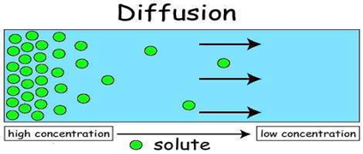

Factors that affect the RATE of diffusion
1- Difference in concentration between the inside and outside of the cell. The bigger the difference between concentrations, the diffusion will be faster.
2- The size of chemical substances. Oxygen is two atoms, glucose is 24 atoms big and protein is massive. Oxygen can easily diffuse across a cell membrane, sugar can kind of, and that’s why it’s assisted by a transporter protein to facilitate it while the proteins don’t move at all.

3- Temperature. Higher temps = molecules move faster.
4- Whether the chemical substance is water-soluble or lipid soluble. The lipid soluble goes faster because the cell membrane is phospholipids and can easily diffuse through a fatty membrane.

b- Facilitated diffusion: is the movement of molecules across the cell membrane via special transport proteins that are embedded within the cellular membrane (integral proteins) so it differs from passive diffusion in that molecules do not dissolve in phospholipids bilayer but their passage is mediated by proteins and this process requires no energy.
Large, insoluble molecules, such as glucose (very essential elements for life and it represents the main source of energy for cells) and proteins require a carrier molecule to move through the plasma membrane. Therefore, it will bind with its specific carrier proteins, and the complex will then be bonded to a receptor site and moved through the cellular membrane.

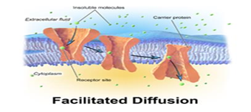

There are two classes of proteins mediate facilitated diffusion
1-carrier proteins are specific, each one or type can transport with only a certain type of molecule or ion, which is then transported through the membrane. For example, various sugar molecules of identical size might be present inside or outside the cell, but glucose can cross the membrane hundreds times faster than the other sugars. For this reason the membrane can be called differentially permeable
2-channel proteins form unblocked pores that allow substances to enter or leave the cell.
Water can pass through phospholipid bilayers by simple diffusion or by facilitated diffusion through special channel proteins called aquaporin's.

c- Filtration
Filtration is the movement of water and solute molecules across the cell membrane due to hydrostatic pressure .Depending on the size of the membrane pores, only solutes of a certain size may pass through it. For example, the membrane pores of the Bowman's capsule in the kidneys are very small, and only albumins which is the smallest type of the proteins and soluble in solute solutions, have any chance of being filtered through.
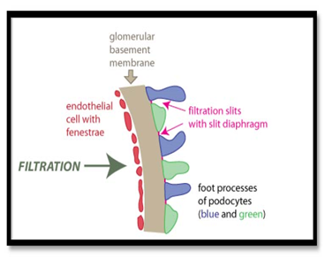
Filtration process in kidney glomeruli

d- Osmosis: is the movement of water molecules across a selectively permeable membrane.
There are three types of Osmosis solutions:

1-Isotonic solution
Isotonic solution is when the extracellular solute concentration is balanced with the concentration inside the cell. In the Isotonic solution, the water molecules still moves between the solutions, but the rates are the same from both directions, thus the water movement is balanced between the inside of the cell as well as the outside of the cell. Tissue ﬂuids and blood plasma are isotonic for body cells.

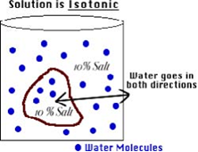

2-Hypotonic solutions
Hypotonic is a solution that is less concentrated than the intracellular ﬂuid, so the water moves into the cell and that can cause the cell to swell up and explode. When the cell is in danger of bursting, organelles called contractile vacuoles will pump water out of the cell to prevent this.

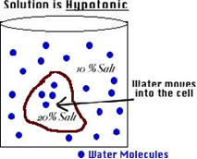

3- Hypertonic solution
Hypertonic solution is when the solute concentration outside the cell is higher than the concentration inside the cell.
In hypertonic solutions, water diffuses out of the cell due to osmosis and the cell shrinks in a process termed crenation.
Thus, the animal cell has always to be surrounded by an isotonic solution.

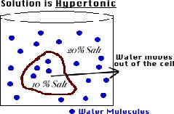

2-Transport mechanisms (requiring energy from cells)
The cell needs to transport molecules against their concentration gradient (from low to high concentration) and that needs energy which provide by ATP hydrolysis.
There are many types of mechanisms that require energy to transport different material across P.M.:

A- Active transport is the movement of substances against its concentration gradient and this process usually related with accumulating high concentrations of substances that the cell needs like glucose, amino acids and ions.
In this case both chemical energy (ATP) and carrier proteins to combine with the substance are needed to transport the molecules or substances against their concentration gradient.
For example the kidney cells have a large number of mitochondria (to create energy) near membranes where active transport is occurring for re-use needed nutrients from the waste like water, amino acids, vitamins and glucose are reabsorbed into blood stream. .

B- Bulk transport is the movement of substances or macromolecules across membrane within a small vacuole that's means that the large molecules and particles move through membrane enclosed by vesicles formed by parts of cell membrane.
These processes are grouped according to whether materials are moved into or out of the cells in which both needs energy as follows:

1-Endocytosis
Cells uptake molecules and particles from surrounding media through plasma membrane to inside the cytoplasm in which material a cross through plasma membrane invigilates to inside the cell to form vesicle containing ingested material. Endocytosis occurs in different ways:

a- Phagocytosis (cell eating)
Occurs when the materials enter the cell in which cells engulf large particles like bacteria and debris. Cytoplasmic process (pseudopodia) of the cell is extended and surrounds the particles and form vesicle called phagosome. Phagosomes then fuse with lysosome to form phagolysosome. Lysosomal enzymes digest the content and the indigested particles are retained within vacuoles which termed residual bodies.
Certain white blood cells like neutrophil and macrophage are specialized for engulfing and removing particles like bacteria and dead cells.
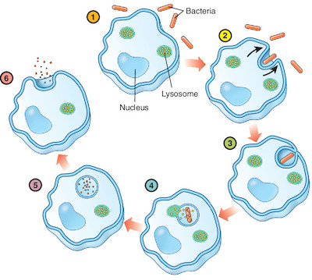
Phagocytosis

b- Pinocytosis (cell drinking)
Occurs when the plasma membrane folds inward to form a channel allowing dissolved substances to enter the cell.
When the channel is closed, the liquid is encircled within a pinocytic vesicle, which then fuse with lysosomes to hydrolyze (break down) the particles. These vesicles then fuse with plasma membrane to release their and release their contents outside the cell. This process is termed transcytosis and requires energy in the form of adenosine triphosphate (ATP).

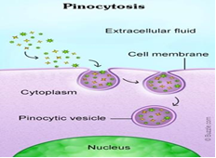

c- Receptor mediated endocytosis
Is the process by which cells absorb specific extracellular molecules called ligands (molecules with high affinity for a receptor) like metabolites, hormones, proteins and in some cases viruses binds directly to specific receptors on the cell membrane before they are internalized by invagination, these receptors coated with the protein called clatherine and known as clatherine-coated pits.
Steps of receptor mediated endocytosis:
1-when many receptors are bound by their ligands they aggregate in some membrane region, then invaginates and forming vesicles (contain both receptors and its bound ligands) to be internalized by endocytosis.
2-The vesicles quickly enter and fused with one or more vesicle of the endosomal compartment (a dynamic system of vesicles and tubules).
3-the acidic PH of endosome makes many ligands separate from their receptors and sorted into other vesicle.
4-the vesicles that empty from receptors return to the cell surface and the receptors can be enclosed in a lipid of the cell membrane to be reused again, while the ligands are typically transferred to endosome which then fused with lysosomes for digestion of their contents.

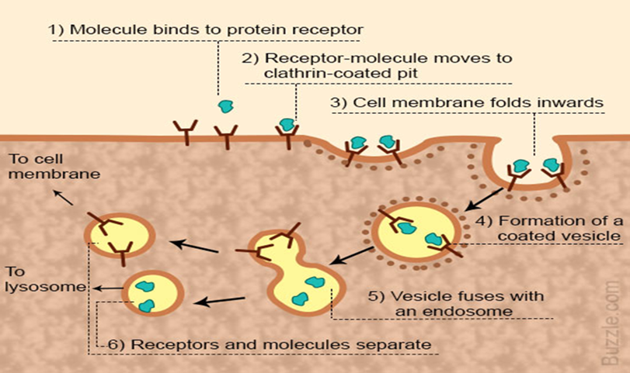

2-Exocytosis
Exocytosis is the opposite of endocytosis (in which substances are taken into cells). In exocytosis molecules like waste products, hormones, and proteins are export out of the cells by secreting them in an energy dependent process.
In exocytosis, membrane-bound vesicles containing large amount of cellular molecules are transported to the cell membrane. The vesicles fuse with the cell membrane and expel their contents to the exterior of the cell.
Both endocytosis and exocytosis are used by all cells and require energy because the important molecules for the cells are large molecules and cannot pass through passive transport so they needs energy to transport this molecules across plasma membrane and making a form of bulk transport for example pancreatic cells and neuron.

